Course Name | ITD 2343 – Object Oriented Programming with C#
Instructor | Mark L. Pranger
Student Name | Eric Christensen
Due date | Nov 11, 2025
Grade | <grade earned here>
Grading Comments | <instructor comments here>

Week 10 – Programming Lab

Screen Shots needed for Submission:
- Make a screen shot for each of the following points in the creation process
  - The form after you have completed all the visual changes specified in the UI design. many of the changes will not show in a screen shot but the color change will
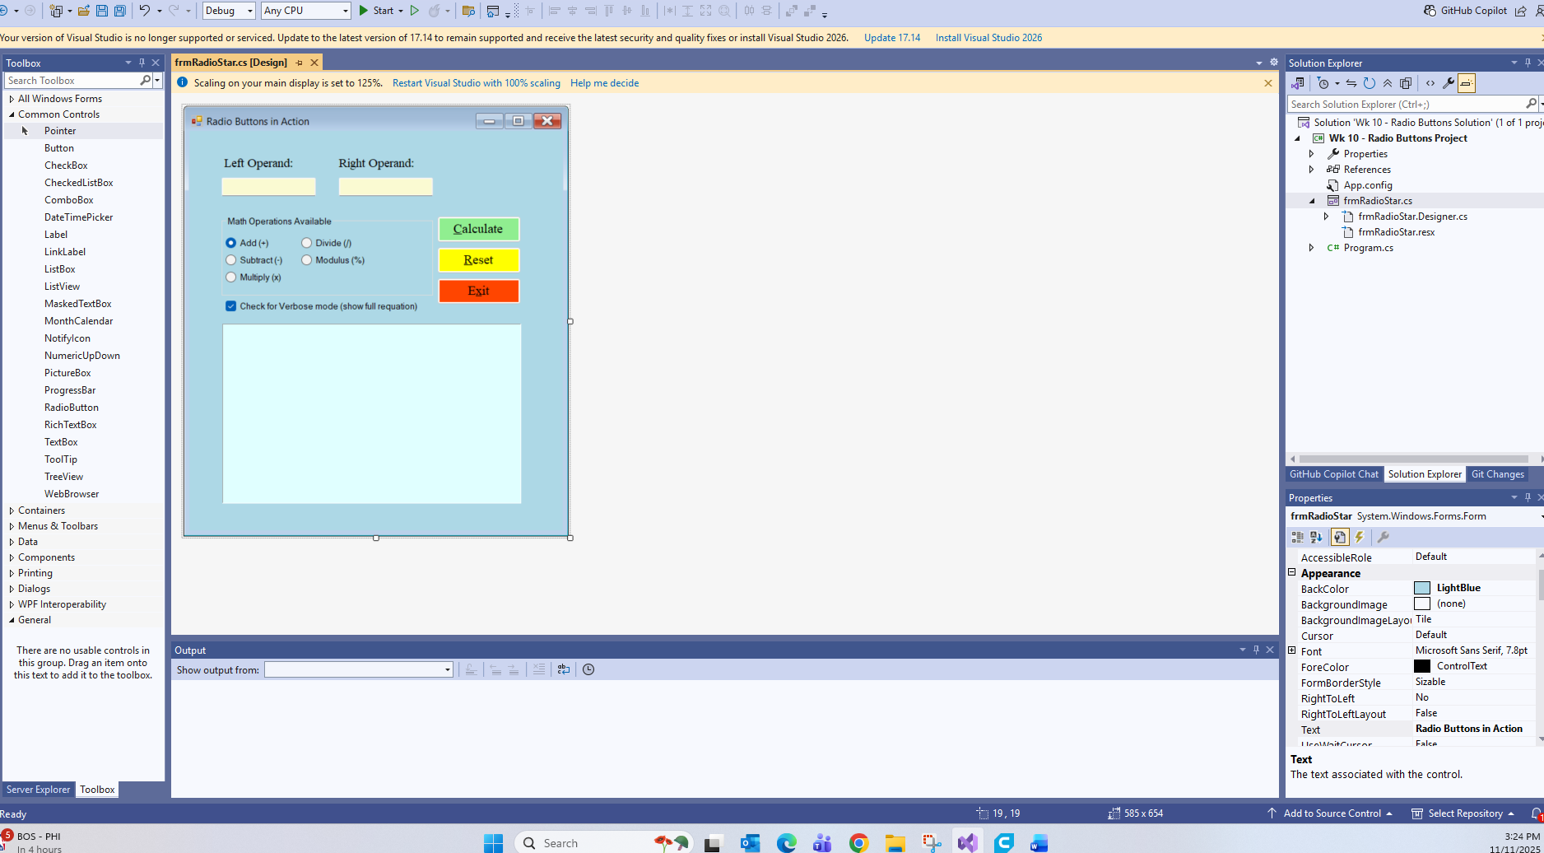
- Run the application in debug mode, screen shot the whole screen showing the form starting up
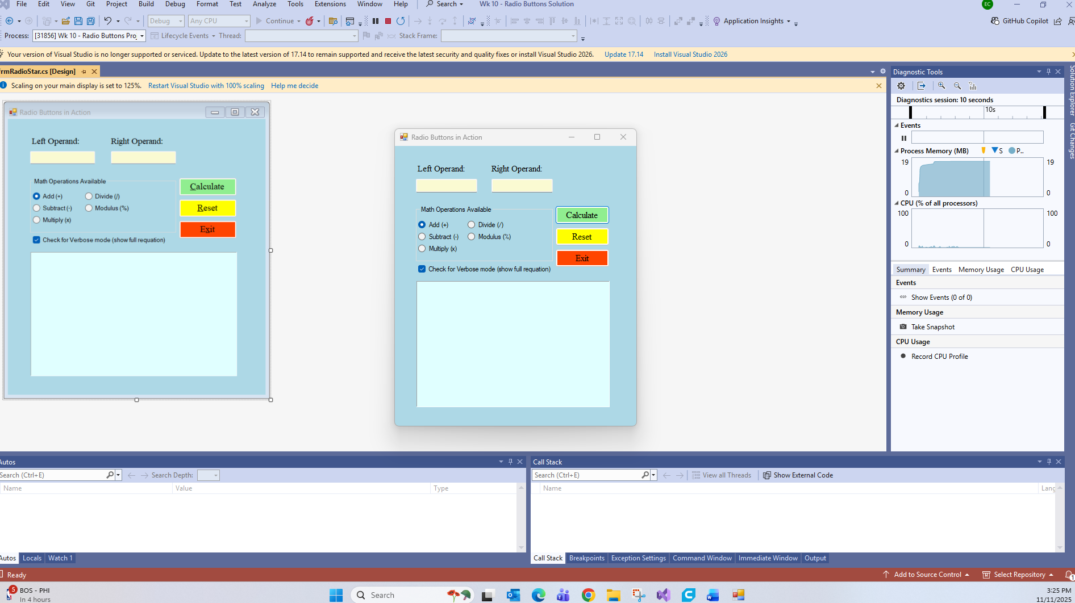
- For the operations screen shots, show one screen shot depicting each of the following scenarios
- Make the following screen shots of the results of the following test case numbers
  - Show one successful operation from each of the 5 radio buttons
    - use the numbers 100 and 29 as the two operands on one set of screen shots showing all 5 radio buttons in use
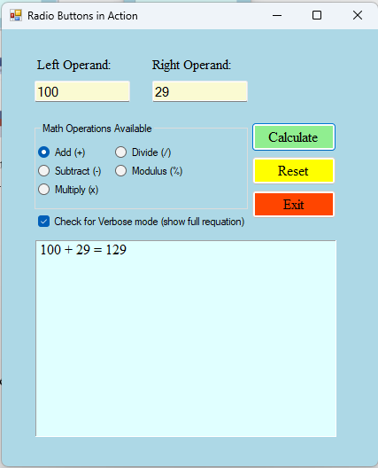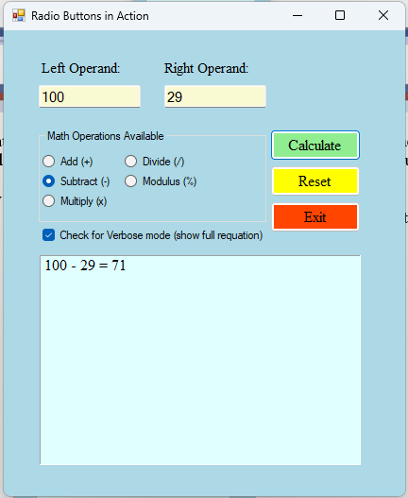
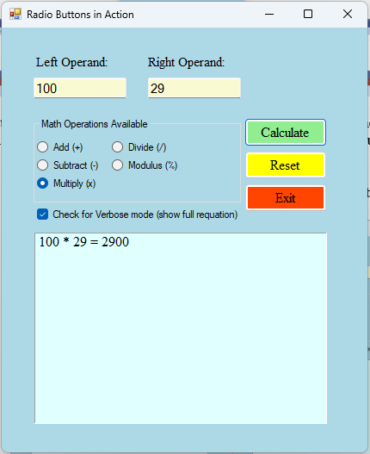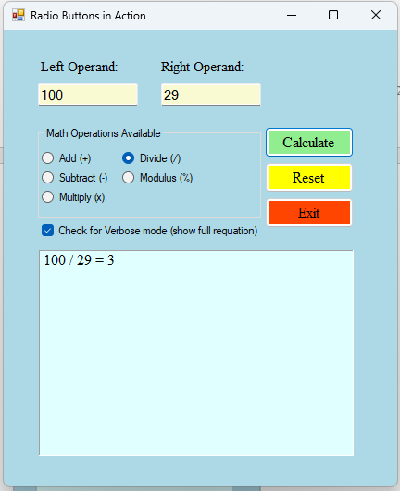
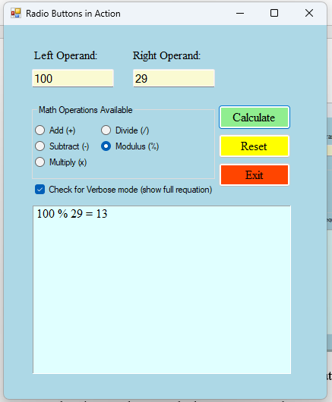
    - then make another set of screen shots showing the radio buttons working using your own set of 2 numbers.
      - The First number must be between 100 and 501
      - The Second number must be between 7 and 50
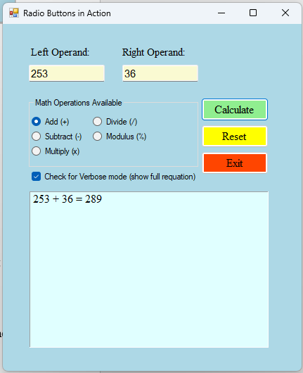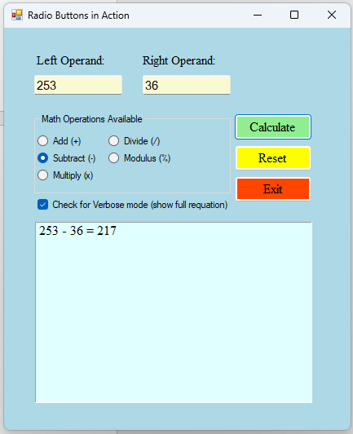
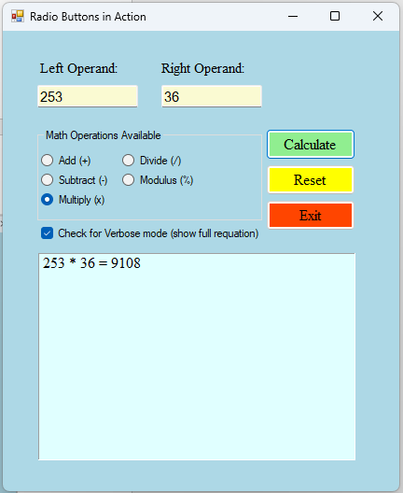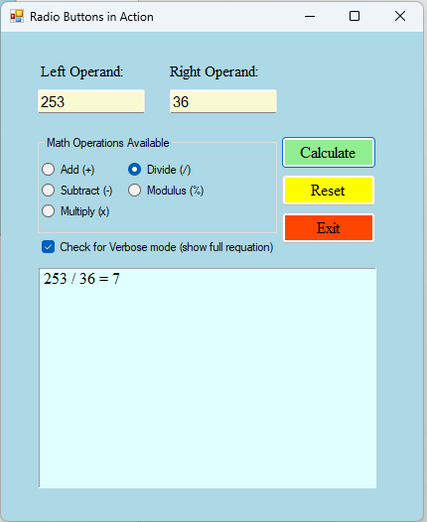
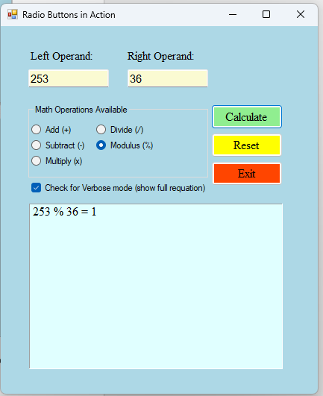
  - Show the error message you get when you use a word for the left operand and the number 0 in the right operand with the divide operation
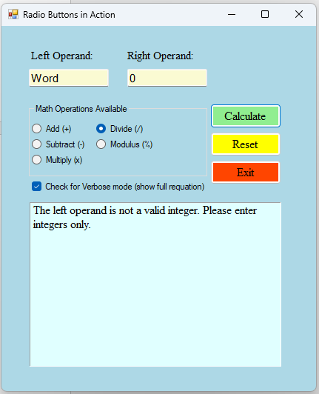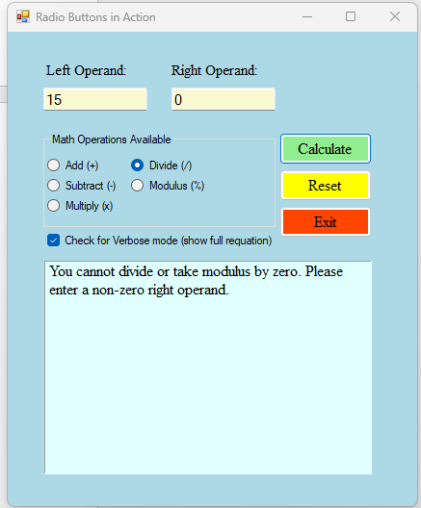
  - Show the error message you get when both operands are blank
